SURVEY:
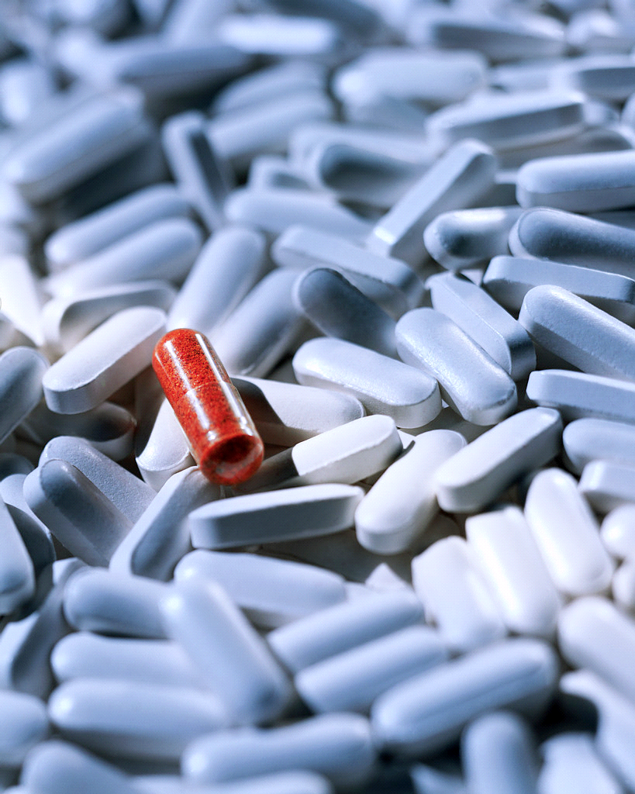
PSYCH LAB EXPERIMENT:
Statistics indicate that the majority of high school students have tried alcohol or marijuana. Write in your journal if you think this is true. Summarize what you think to be true of your prior knowledge ( ie most have tried, most have not tried etc).
Your job is to develop a survey in which high school students are asked their age and types of substances they have a) tried or b) use regularly. Substances should include alcohol, marijuana, tobacco, cocaine, and so on. You may want to do a search on commonly used names for different substances. Obviously, you will write a confidentiality phrase stating that the results will not be shared. It will be anonymous!
You might want to have a section where they can comment or state where they think the drug is dangerous or not!
This survey is a school wide survey. There will be one drop off box for completed surveys throughout the school. We will go through the drop box at the end of next week. Please set a collection due date.
You will be asked to collect 25 samples of student’s responses and chart the results by age and substance. Write an interpretation of your results. Based on your results, you will write up a one page summary highlighting a drug that you would like to focus on.
Please come with your survey portion completed for Monday!
Please hand in this rubric with your assignment. See rubric below.
Bring POSTER PAPER for next week.

Name:____________________________________________
Mark/ 20
1=least 5= most
Demonstrates adequate time and effort put forth
1 2 3 4 5
Informative/Shows application of learning
1 2 3 4 5
Creative/Expresses learning in a diversified way
1 2 3 4 5
Comprehensive survey- Outlines main questions- Hand in your responses
1 2 3 4 5

